Abala Rd,
Marrara NT 0812
PO Box 2391
Parap NT 0804
Tel: 08 8945 1733
office@netballnt.org.au
www.nt.netball.com.au

Service Excellence Awards 2022

Recently the Member Associations of Netball NT adopted a new Constitution and subsequent to that the Board of Netball NT adopted a set of By-Laws and included amongst them was provision of the recognition to Individual Members who have given at least ten (10) years outstanding service to netball.

Clause 19 of the Netball NT By-Laws reads as follows

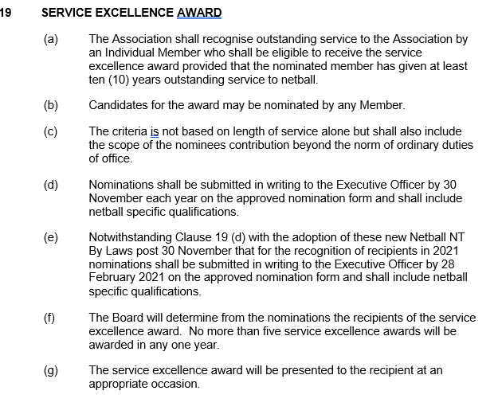

Nominations are now called for the 2022 Service Excellence Awards

Nominations close at 5:00pm on Tuesday 30th November 2021 and are to be returned by post or email to:
Ian Harkness, Executive Officer
PO Box 2391
Parap NT 0804
Email: office@netballnt.org.au
Once your nomination has been received, you will be sent a confirmation email.

Please complete the following sections and, if necessary, attach an extra sheet if more room is required.

Nominee Name

Address

Telephone

Email

Club/Association

Nominated by

Address

Telephone

Email

Association

Netball Background (Please use point form )
Highlight outstanding achievements or initiatives related to award.

Club Netball Contribution (if any)

_____________________________________________________________________

Member Association Netball Contribution (if any)

_____________________________________________________________________

Netball NT Contribution (if any)

_____________________________________________________________________

