Abala Rd,
Marrara NT 0812
PO Box 2391
Parap NT 0804
Tel: 08 8945 1733
office@netballnt.org.au
www.nt.netball.com.au

Life Membership Nomination Form

Netball NT has a proud history of individuals who have provided long and meritorious service with the Association and who have been recognised with the awarding of Life Membership.

The Honour Board of Netball NT Life Members reads as follows:

- 1988 – Shirley Richards
- 1991 – Patricia Gallagher
- 1991 – Anne Hosking
- 1991 – Margaret McPherson
- 1999 – Sandy Mackintosh
- 1999 – Karen Schneider*
- 1999 – Riley Wing*
- 2011 – Helen Smith
- 2011 – David Yeaman
- 2011 – Thea Pearce
- 2021 – Anthony (Tony) Smith

The recent adoption of both a new Constitution and By Laws encompasses section relative to the awarding of Life Membership as follows:

Clause 5.3 of the Netball NT Constitution

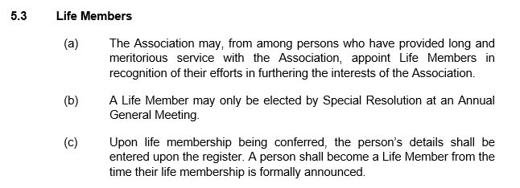

Clause 18 of the Netball NT By Laws

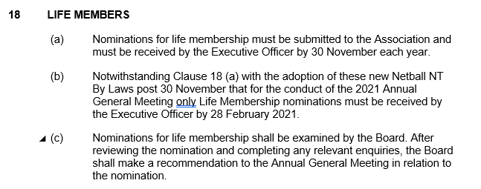

In accordance with both of these sections of the governing documents Netball NT now seeks any Nominations for consideration as a Life member of Netball NT

Nominations close at 5:00pm on Tuesday 30th November 2021 and are to be returned by post or email to:
Ian Harkness, Executive Officer
PO Box 2391
Parap NT 0804
Email: office@netballnt.org.au
Once your nomination has been received, you will be sent a confirmation email.

Please complete the following sections and attach as many extra sheets as is deemed appropriate to support the nomination.

Nominee Name

Address

Telephone

Email

Club/Association

Nominated by

Address

Telephone

Email

Association

Netball Background (Please use point form and attach an extra sheet if more room is required)
Highlight outstanding achievements or initiatives related to award.

